DEGICHI QUIZ
FINAL SEMESTER EXAM PROJECT REPORT
(Prepared to fulfill the requirements for passing the Final Exam Semester 1)



By :
Dentar Muhammad Ababilla (25031554277)
Ghita Natasha Putri (25031554023)
Orchidea Savira Putri Arief Dhidin (25031554174)

Lecturer: Hasanuddin Al-Habib, S.Si., M.Si
Siska Puspitaningsih, S.Kom., M.Kom

STUDY PROGRAM DATA SCIENCE
FACULTY OF MATHEMATICS AND NATURAL SCIENCES STATE UNIVERSITY OF SURABAYA
2025

TABLE OF CONTENTS

DEGICHI QUIZ 1
TABLE OF CONTENTS 1
CHAPTER 1 INTRODUCTION 2
1.1 BACKGROUND 2
1.2 PROBLEM STATEMENT 2
1.3 OBJECTIVES 3
CHAPTER 2 ANALYSIS AND DESIGN 4
2.1 APPLICATION NECESSITY ANALYSIS 4
2.2 FLOWCHART 6
2.3 USER INTERFACE DESIGN SKETCH 7
CHAPTER 3 IMPLEMENTATION 8
3.1 CODE EXPLANATION 8
3.2 APPLICATION SCREENSHOTS 37
CHAPTER 4 ATTACHMENT 40
4.1 Embed File 40
REFERENCES 41

CHAPTER 1 INTRODUCTION

BACKGROUND
Degichi Quiz is a digital quiz platform developed to help students strengthen their abilities through a wide range of questions from various subject areas. By offering diverse, challenging, and informative question sets, this project aims to enhance students’ understanding and support independent learning in a more structured way.
In addition to improving learning quality, Degichi Quiz is designed to minimize cheating during quiz sessions. Through monitoring and activity-restriction features similar to Exambro, the platform ensures a more honest, secure, and objective evaluation process.
With a modern, user-friendly interface, Degichi Quiz provides an interactive quiz experience that encourages a disciplined and responsible learning environment. This project is expected to serve as an effective evaluation tool while supporting students’ overall skill development.

PROBLEM STATEMENT
Many students in Indonesia struggle to develop their academic abilities effectively due to limited access to interactive and secure digital evaluation tools. Traditional quiz methods often lack engaging features and are vulnerable to cheating, which reduces the accuracy of assessments and weakens students’ learning outcomes. As a result, students may have low motivation, unreliable performance results, and limited opportunities to practice their knowledge in a disciplined environment.
To address this issue, we developed Degichi Quiz, a modern digital quiz platform designed to provide an interactive, structured, and secure learning experience. By offering diverse question sets across multiple subjects and integrating anti-cheating features similar to Exambro, this platform ensures a fair and focused evaluation process. Degichi Quiz aims to help students improve their understanding, strengthen their discipline, and build confidence while fostering a more honest, engaging, and effective approach to academic assessment.

OBJECTIVES
The purpose of making this Degichi Quiz includes:
    - To create a user-friendly digital quiz platform that is accessible and easy for
students to use.
    - To implement secure and efficient systems that support question delivery and minimize cheating during quiz sessions.
    - To design a modern, intuitive, and visually appealing interface that improves students’ quiz-taking experience.
    - To provide an interactive learning and evaluation tool that helps students strengthen their academic skills across various subjects.
    - To promote honest, disciplined, and independent learning through a controlled and well-structured digital assessment environment

CHAPTER 2 ANALYSIS AND DESIGN

APPLICATION NECESSITY ANALYSIS
The Degichi Quiz application is developed as a modern and secure digital evaluation platform that promotes independent learning. The necessity of this application can be summarized into three main needs as follows:
    - Interactive & Engaging Digital Assessment
      - Digital and gamified quiz platforms have been proven to increase student engagement and motivation. A study published in the International Journal of Educational Technology in Higher Education (2018) found that adaptive gamified quizzes helped students stay more engaged and improved learning outcomes.
      - Degichi Quiz supports step-by-step question presentation, instant feedback, and modern interface design. These features create an active learning environment that encourages students to reflect on their answers, understand mistakes, and remain focused throughout the quiz.
      - Such interactive systems transform assessments from simply “answering questions” into a more meaningful learning experience, helping students strengthen conceptual understanding and develop higher-order thinking skills.
    - Secure, Anti-Cheating, and Reliable Evaluation System
      - Research shows that academic dishonesty increases significantly in online examinations without proper monitoring or preventive measures. A systematic review in the Journal of Academic Ethics (2023) revealed that cheating during online exams can reach 30–50%, depending on exam type and supervision levels.
      - To reduce dishonesty, Degichi Quiz integrates essential security features such as session authentication, time-limited assessments, restricted navigation, and activity monitoring. These mechanisms help create fairer, more objective evaluations.
      - With reliable system stability and secure data handling, teachers can trust the results presented by the platform, making the evaluation process more credible and accountable.
    - Data-Driven Learning & Independent Study Support
- According to the UNESCO Global Education Monitoring Report (2023), data-driven evaluation systems significantly improve the effectiveness of learning because they allow educators to track progress and identify learning gaps more accurately.
- Degichi Quiz stores comprehensive information such as quiz scores, learning progress, and individual performance statistics. These analytics help teachers design more targeted instruction and help students understand their strengths and weaknesses.
- The availability of progress data also supports self-paced and independent learning, enabling students to revisit topics, retry quizzes, and build confidence without external pressure.

FLOWCHART
As a digital evaluation medium, Degichi Quiz offers major advantages in terms of interactivity, security, and independent learning support. The system not only measures learning outcomes but also creates a more active, honest, and structured evaluation experience for students. To ensure that the application’s process can be understood clearly, a workflow diagram is needed to illustrate how users interact with the system from beginning to end.
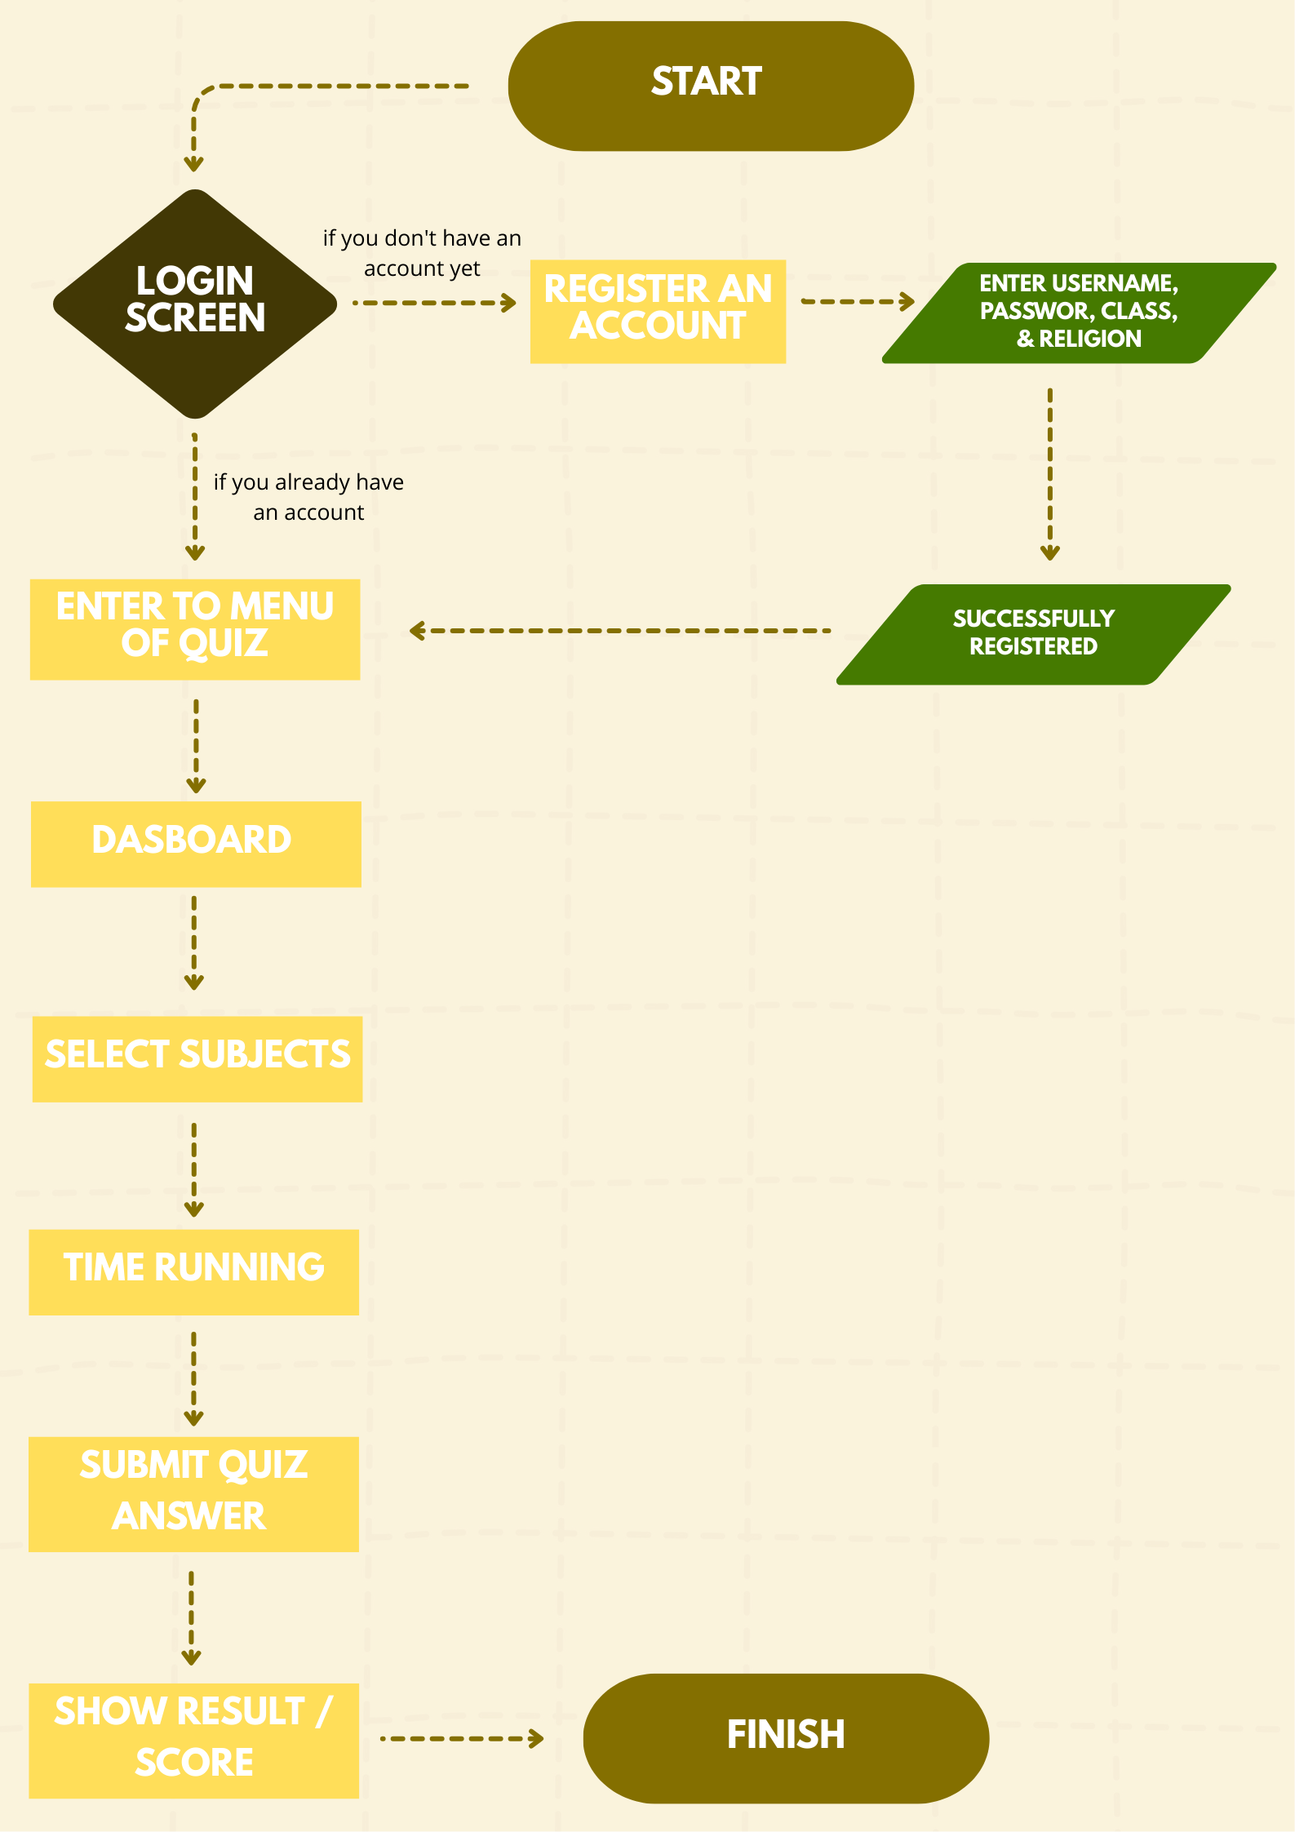
The flowchart below presents the main operational flow of the application in a structured manner.

USER INTERFACE DESIGN SKETCH

    - Login Page Components:
- Dark academic background with formulas and doodles.
- Center title: “DEGICHI”
- Input Form:
  - Username
  - Password
  - Show Password Checkbox
- Buttons:
  - “Masuk”
  - “Daftar”

    - Registration Page Components:
- Same background theme as login.
- Tittle: “Daftar Akun Baru”
- Input Form:
  - Username
  - Password
  - Konfirmasi Password
  - Kelas
  - Agama
- Button: “Daftar Sekarang”

    - Selection Category
Components:
      - Title: “Pilih Mata Pelajaran”
      - Six Subject Cards:
        - Matematika
        - Fisika
        - Kimia
        - Biologi
        - Bahasa Indonesia
        - Bahasa Inggris
        - PKN
        - Sosiologi
        - Ekonomi
        - Sejarah
        - Matematika Lanjut
        - Olahraga
        - Agama
      - Buttons-right: “Keluar”

    - Main Quiz Components:
- Top bar:
  - Timer
  - XP
  - Level
  - Menu icon.
- Header: Question X of 20
- Question text and four answer options (A–D).
- Penalties: –5 min, –10 min, –20 min
- Botton: “Soal Berikutnya“

    - Quiz Result
Components:
      - Title: “Quiz Completed!”
      - Score box:
        - Final Score
        - Time Left
        - XP Obtained
        - Level
        - Power-up used
      - Buttons:
        - “Cetak PDF”
        - “Kembali ke Dasboard”
    - Result in PDF
      - Result like a raport

CHAPTER 3 IMPLEMENTATION

CODE EXPLANATION
Implementation of the Degichi – Digital Exam & Gamified Cbt application is carried out using the Python programming language, the PyQt5 framework for building the graphical user interface (GUI), and SQLite as the storage system for user data and XP progression. The code consists of several main components, including theme configuration, database system, UI components, question loader, power-up system, question navigation mechanism, time management, and exam result generation in PDF format.
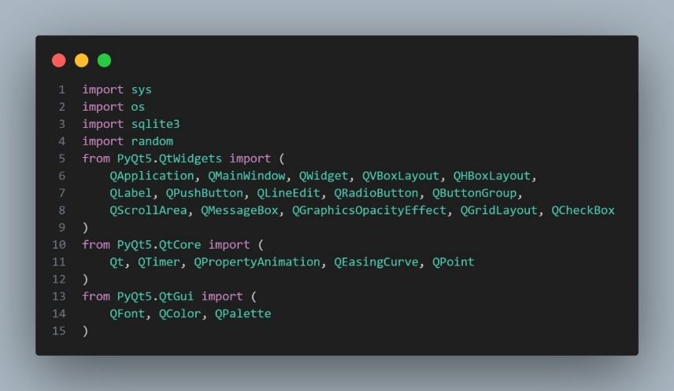
The following section provides a systematic explanation of the code structure and its functions

Gambar 3. 1 Libraries for Degichi Quiz
Source: Personal documentation

Importing Libraries:
- PyQt5 – used to build the application interface such as windows, buttons, layouts, radio buttons, message boxes, scroll areas, animations, timers, and visual effects.
- sqlite3 – used to store and manage user data, including username, password, XP, class, and religion.
- random – used to shuffle questions and generate random visual effects such as confetti.
- reportlab – used to generate PDF files for downloadable exam reports.
- datetime – used to add timestamps to reports and activity logs.
- os & sys – used to manage file paths, access assets, read question files, and control application execution.
- QTimer, QPropertyAnimation, QEasingCurve – used to handle countdown timers and smooth UI animations.
- QFont, QColor, QPalette – used to style the application’s visual theme, colors, and typography.
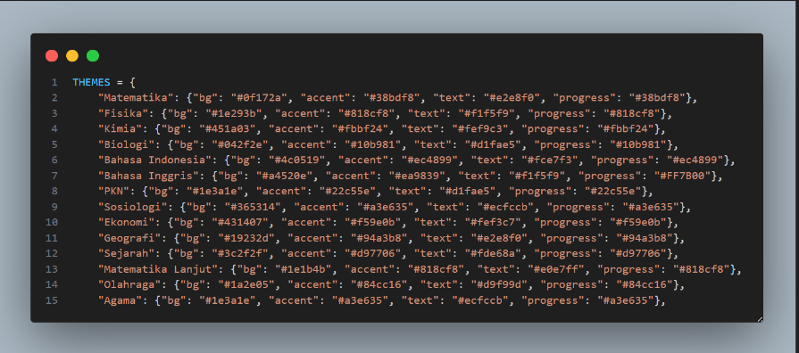

Gambar 3. 2 The code of Degichi Quiz
Source: Personal documentation
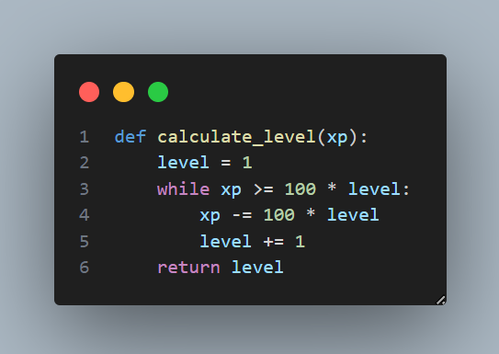
The code snippet contains a constant dictionary named THEMES. This dictionary is used to store theme configurations for different school subjects in the Degichi Quiz project. Each subject is assigned visual styling values including background color, accent color, text color, and progress indicator color. These color styles help ensure that each selected subject displays a unique and consistent UI appearance throughout the application.
Gambar 3. 3 The code of Degichi Quiz
Source: Personal documentation
This function calculates a player’s level based on their XP. It starts from level 1 and keeps increasing the level as long as the XP is enough to pay the required amount (100 × current level). Each level-up reduces XP by that amount. When the XP is no longer sufficient, the function returns the final level.
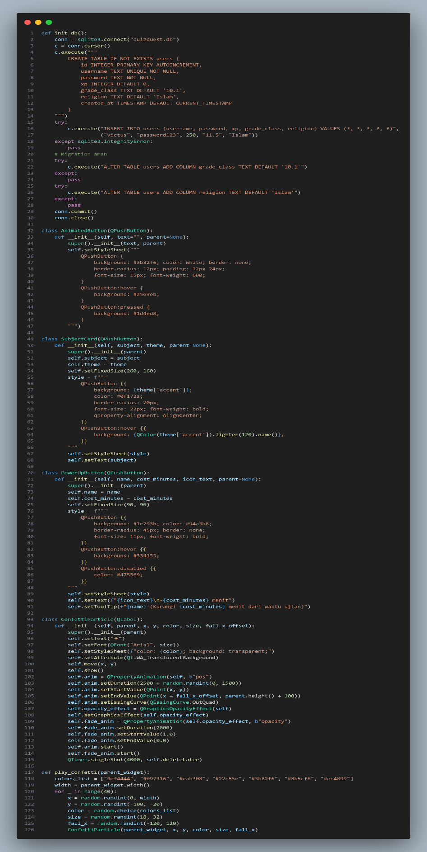
Gambar 3. 4 The code of Degichi Quiz
Source: Personal do cumentation
init_db Function : Prepares the database and ensures all required fields exist before the app runs.

Key Components:
- sqlite3.connect("quizquest.db") : Connects to the main database file.
- CREATE TABLE IF NOT EXISTS users (...) : Creates the users table containing id, username, password, XP, class, religion, and timestamp.
- ALTER TABLE command : Adds missing columns (grade_class, religion) if they don’t exist acts as a “migration”.
- INSERT INTO users (...) : Inserts a default admin/testing account.
- conn.commit() : Saves all changes to the database.
This function ensures your quiz/exam app has a complete user table ready to store login accounts and student information, similar to login systems in exam browsers or Quizizz.
AnimatedButton Class : Creates a specially-styled button with hover and click animations.

Key Components:
- setStyleSheet(""" ... """) : Defines custom colors, padding, border radius, and font styling.
- QPushButton:hover : Changes button color when the user hovers.
- QPushButton:pressed : Changes style when clicked.
This class generates modern buttons to improve the UI experience so the app feels more interactive and game-like.
SubjectCard Class : Generates clickable subject cards (Math, Biology, etc.) with themed colors.

Key Components:
- self.subject : Stores the subject name displayed on the card.
- self.theme : Loads color themes from the THEMES dictionary.
- setFixedSize(260, 160) : Sets the card size.
- Dynamic stylesheet : Displays subject-specific colors and hover effects.
This class displays each subject as a stylish card that students can click similar to selecting quizzes by subject in Quizizz.
PowerUpButton Class : Provides power-up buttons (clue, 50:50, reveal) used during quizzes.

Key Components:
- self.cost_minutes : Deducts time when a power-up is used.
- Circular button design : Created through custom border-radius and colors.
- setToolTip()
Shows descriptions like “Reduce 10 minutes to get a hint”.
This class creates in-quiz helper buttons to mimic Quizizz-style power-ups, adding a game-like strategy element.
ConfettiParticle Class : Creates a floating confetti effect when a student finishes the quiz.

Key Components:
- QGraphicsOpacityEffect : Makes confetti fade out.
- QPropertyAnimation : Controls movement and fade animations.
- setText() : Confetti particles are generated as small colored text labels.
This class animates decorative confetti that falls and fades, used as celebration feedback to motivate students.
play_confetti Function : Spawns multiple ConfettiParticle objects at once for celebration.
Key Components:
- colors_list : Stores many confetti color options.
- Randomized x-position, size, and fall direction : Creates natural-looking confetti movement.
- Loop (for _ in range(40)) : Generates around 40 confetti particles.
This function produces the full party effect, dropping many animated confetti pieces when the quiz ends successfully.

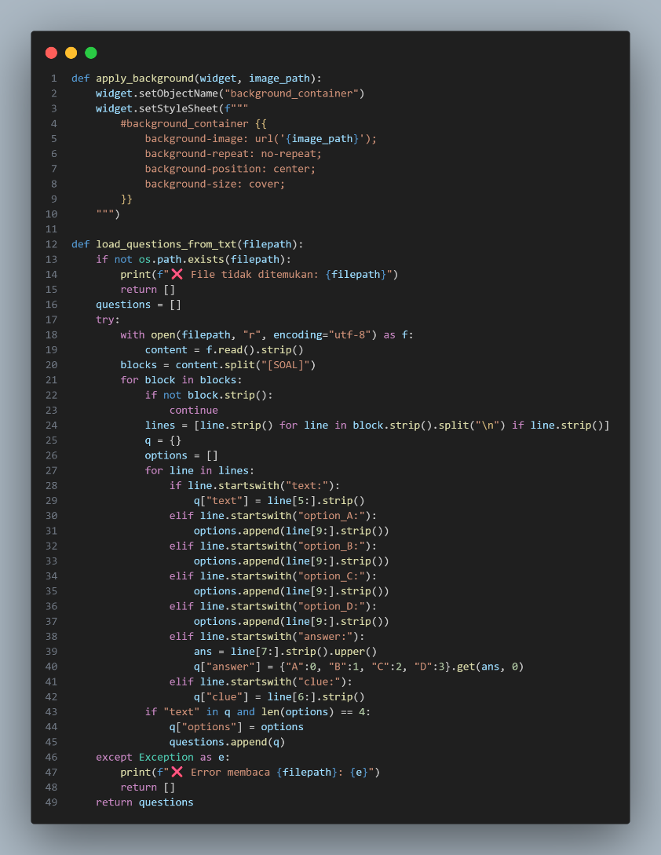

Gambar 3. 5 The code of Degichi Quiz
Source: Personal documentation

apply_background Function : Ensures each screen (subject page, quiz page, etc.) displays the correct themed background—similar to Quizizz’s subject-based visuals.
Key Components
- widget.setObjectName("background_container") : Assigns an object name so the widget can be styled using QSS.
- widget.setStyleSheet(...) : Applies a CSS-style background using the provided image_path.
load_questions_from_txt Function : Converts teacher-made text files into usable quiz questions, supporting the exam system’s flexibility (different subjects, classes, and formats). This allows your app to work like Quizizz but still controlled like an exam browser.
Key Components
- os.path.exists(filepath) : Checks if the question file exists.
- open(filepath, "r", encoding="utf-8") : Reads the entire text content from the file.
- content.split("[SOAL]") : Splits questions using a custom block marker.
- for line in block.strip().split("\n") : Processes each line of a question block.
- line.startswith("text:") : Detects question text.
- option_A / option_B / option_C / option_D : Extracts answer options.
- line.startswith("answer:") : Retrieves the correct answer letter.
- line.startswith("clue:") ; Loads hint text for the power-up system.
- questions.append(q) : Stores the final parsed question object

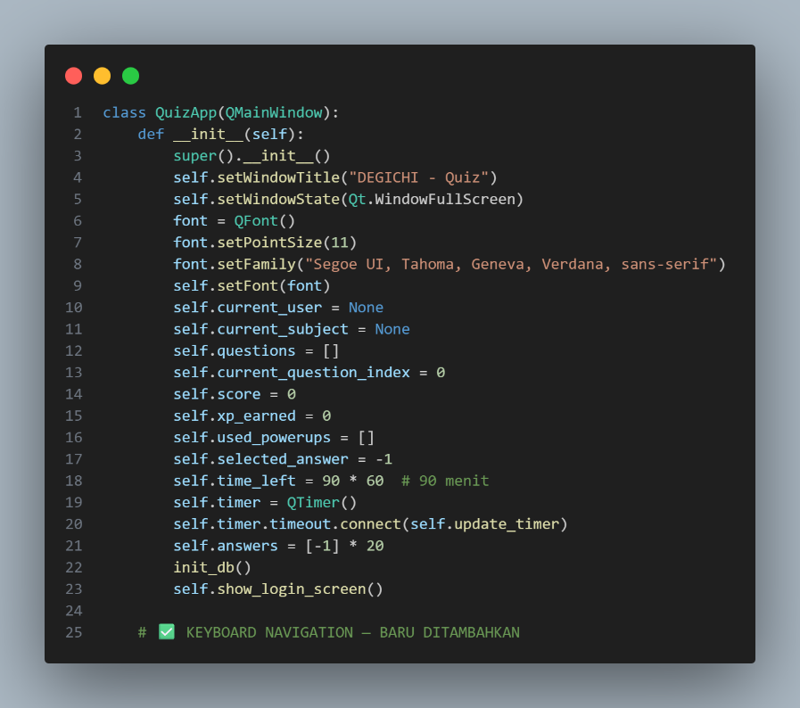

Gambar 3. 6 The code of Degichi Quiz
Source: Personal documentation

__init__(self) Function : method prepares everything the quiz system needs before a student can start the exam.
Key Components and Theis Roles in the Degichi Quiz code :

- Window Setup
- super().init()
Initializes the QMainWindow base class so the app works as a full PyQt window.
- self.setWindowTitle("DEGICHI - Quiz")
Sets the quiz platform title.
- self.setWindowState(Qt.WindowFullScreen)
Opens the app in fullscreen to mimic ExamBrowser (prevent tab-switching).

- Font Configuration
QFont(), setPointSize(11), setFamily(...)
Applies a clean, readable global font for all text elements during the exam.
- User & Subject Tracking
- self.current_user = None
Stores the logged-in student’s account.
- self.current_subject = None
Tracks which subject is selected (Math/Bio/etc.), similar to Quizizz topic selection.
- Question Management
- self.questions = []
Holds all loaded questions from the .txt bank.
- self.current_question_index = 0
Tracks which question is currently being answered.
- Scoring & Gamification
- self.score = 0
Total correct answers.
- self.xp_earned = 0
XP reward for leveling (Quizizz-style progress).
- self.used_powerups = []
Logs used power-ups (Clue, 50:50, Reveal).
- self.selected_answer = -1
Stores the chosen answer for the active question
- Timer System
- self.time_left = 90 * 60
Sets a 90-minute exam duration.
- self.timer = QTimer()
Creates the countdown timer.
- self.timer.timeout.connect(self.update_timer)
Updates the time every second + reacts to time penalties from power-ups.
- Answer Storage
self.answers = [-1] * 20
Holds all 20 answers for scoring, review, and generating results.
- Database Initialization
init_db()
Prepares the user database (accounts, XP, classes, religion).
Ensures persistent login like a real learning platform.
- Launch Login Screen
self.show_login_screen()
Opens the login interface as the first screen for students.

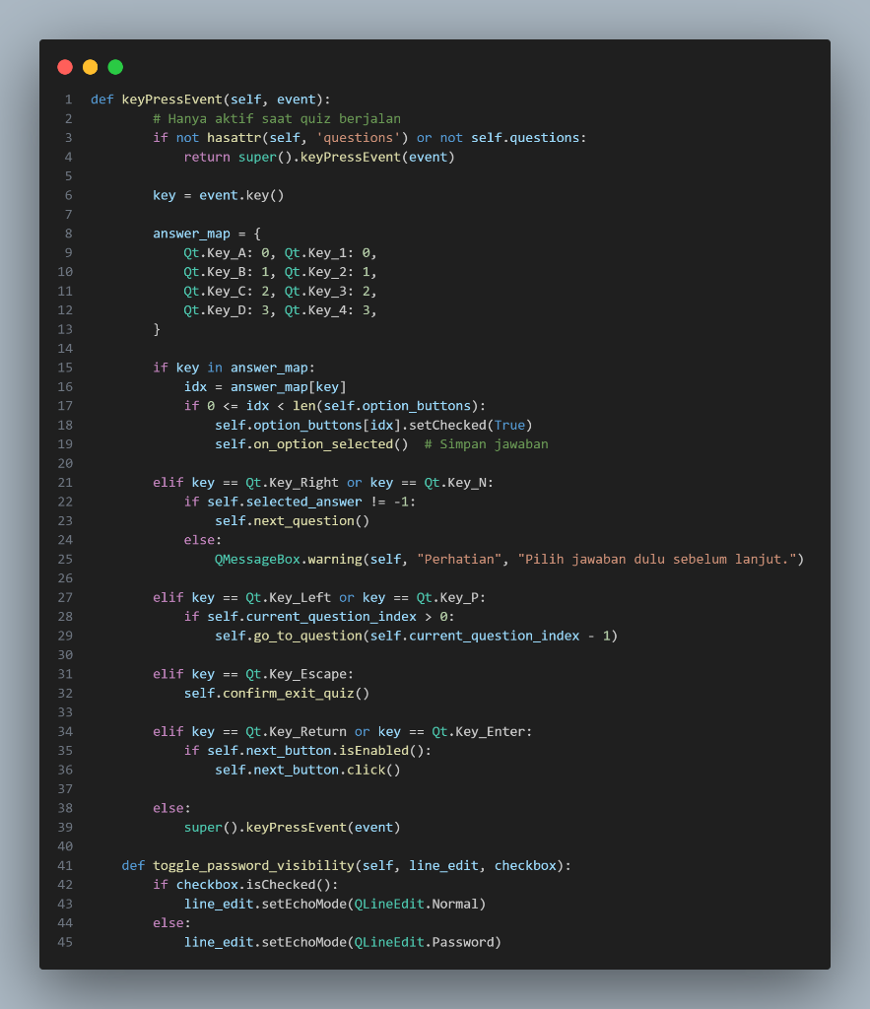

Gambar 3. 7 The code of Degichi Quiz
Source: Personal documentation

This code is part of the Degichi Quiz application, a learning quiz system that combines features similar to Quizizz (game-based learning) and Exambro (anti-cheating system). The main purpose of this code is to control the quiz using the keyboard, so students can answer quickly and stay focused without relying on the mouse.

keyPressEvent() Function : This function handles what happens when a key is pressed:
- Press A / B / C / D or 1 / 2 / 3 / 4 → selects an answer instantly
- Press Right Arrow / N → moves to the next question (only if an answer is selected)
- Press Left Arrow / P → goes back to the previous question
- Press Enter → automatically triggers the “Next” button
- Press Escape → opens a confirmation dialog before exiting the quiz
These controls help increase answering speed, create a game-like experience, prevent students from skipping questions, and keep them focused in the quiz environment to reduce cheating behavior.

toggle_password_visibility() Function : This function is used on the login screen, It allows the password to be shown or hidden depending on the checkbox condition. This feature helps students ensure they type the correct password while still maintaining login security.

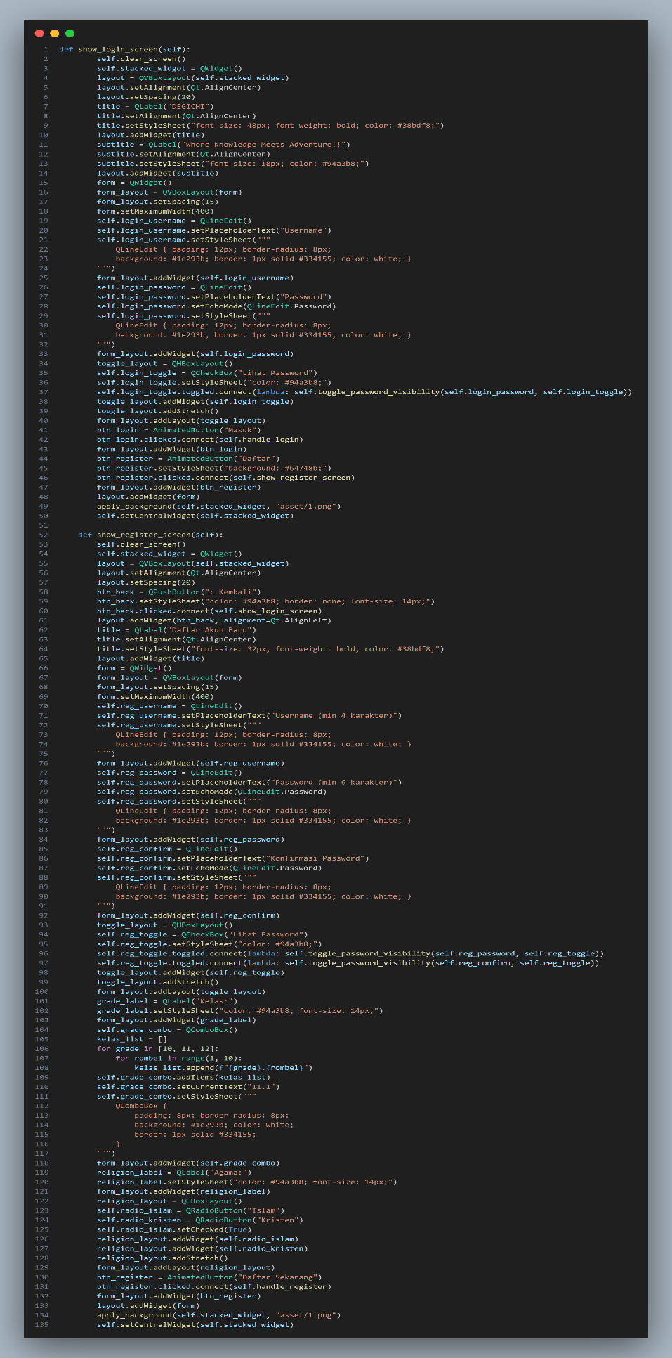
Gambar 3. 8 The code of Degichi Quiz
Source : Personal documentation
This part of the Degichi Quiz program is responsible for displaying the Login Screen and Register Screen. Both screens are created using PyQt widgets and layouts to build a clean, modern interface that students can easily interact with.
show_login_screen(self) Function :
This function displays the main login interface:
  - Main objectives:
- Allow users (students) to enter their username and password
- Provide a button for Login and a Register option to create a new account
- Display a title and tagline to make the UI look more like a learning platform
  - Important UI components:
- QLabel → displays title and subtitle text
- QLineEdit → input fields for username & password
- AnimatedButton → styled interactive buttons
- QCheckBox → "Show Password" feature
- VBoxLayout & HBoxLayout → create a structured and centered layout
The password field uses:
setEchoMode(QLineEdit.Password)→ to hide characters for security.
There’s also a connected function:
self.togle_password_visibility(self.login_password, self.login_toggle)→ lets the user toggle between showing and hiding the password.
Buttons behavior:
- Login button → calls self.handle_login()
- Register button → switches to the register screen using self.show_register_screen()
The background image is applied to make the login page visually appealing.
show_register_screen(self)Function :
This function displays the account creation screen:
- Main objectives:
- Let users register before joining the quiz platform
- Ensure valid and complete data is provided

- Fields provided:
- Username (with minimum length requirement)
- Password (minimum 6 characters)
- Confirm Password (must match)
- Grade selection (dropdown: class 10, 11, 12)
- Religion selection using radio buttons
The UI structure is similar to the login screen so the design stays consistent.
Each input field has custom styling to match the theme of Degichi Quiz.
- Important functional behavior:
- The toggle checkbox also shows/hides both password fields to prevent typing mistakes
- The register button calls self.handle_register() to process the account data
- A "Back" button allows returning to the login screen easily
This design helps ensure:
- Students enter correct login information
- Smooth navigation between screens
- Clean and accessible UI supporting learning environment
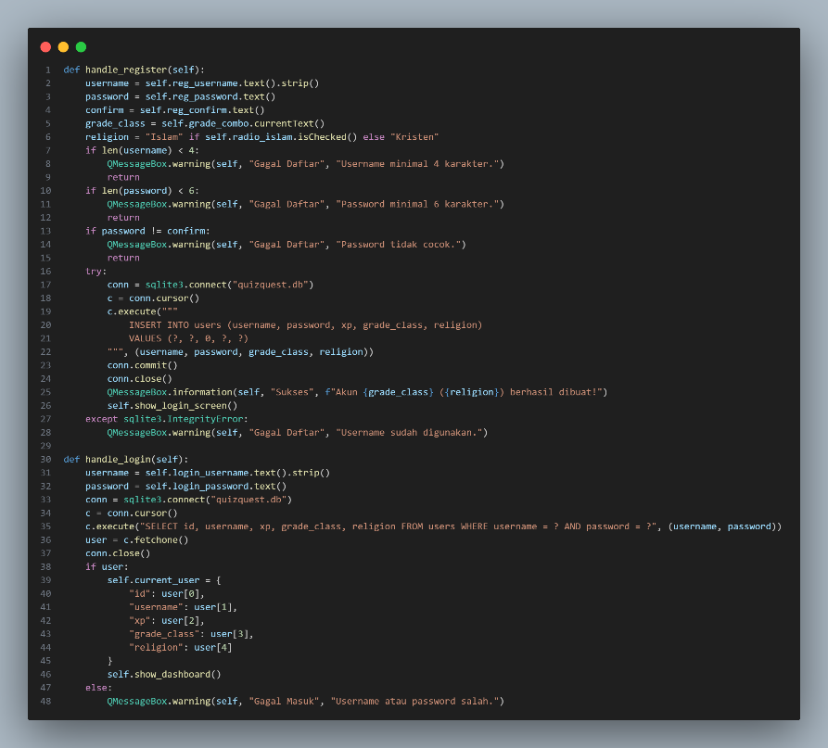
Gambar 3. 9 The code of Degichi Quiz
Source: Personal documentation

Degichi Quiz is a learning game where each student needs a personal profile so their progress, XP, and school data can be tracked. These two functions work as the entry point into the whole system.
handle_register(self) Function : This function is responsible for creating new student accounts. It takes all the information that the student entered in the registration form (username, password, class, religion) and saves it as their identity in the game.
- It ensures every player has a unique profile
- The game can store XP and update progress every time they answer quizzes
- School-required data (grade & religion) are recorded properly
- The student can return later and continue learning from where they left off
If the username is already used, the function stops and asks the student to choose another one.
handle_login(self) Function : This function is used when a student returns and wants to access their existing profile. It checks whether the username and password match a registered student.
- The player’s stored data (including XP and class) is loaded
- The game sends them to the dashboard
- They continue their quiz journey seamlessly
If the account does not match, an error message appears and login is denied
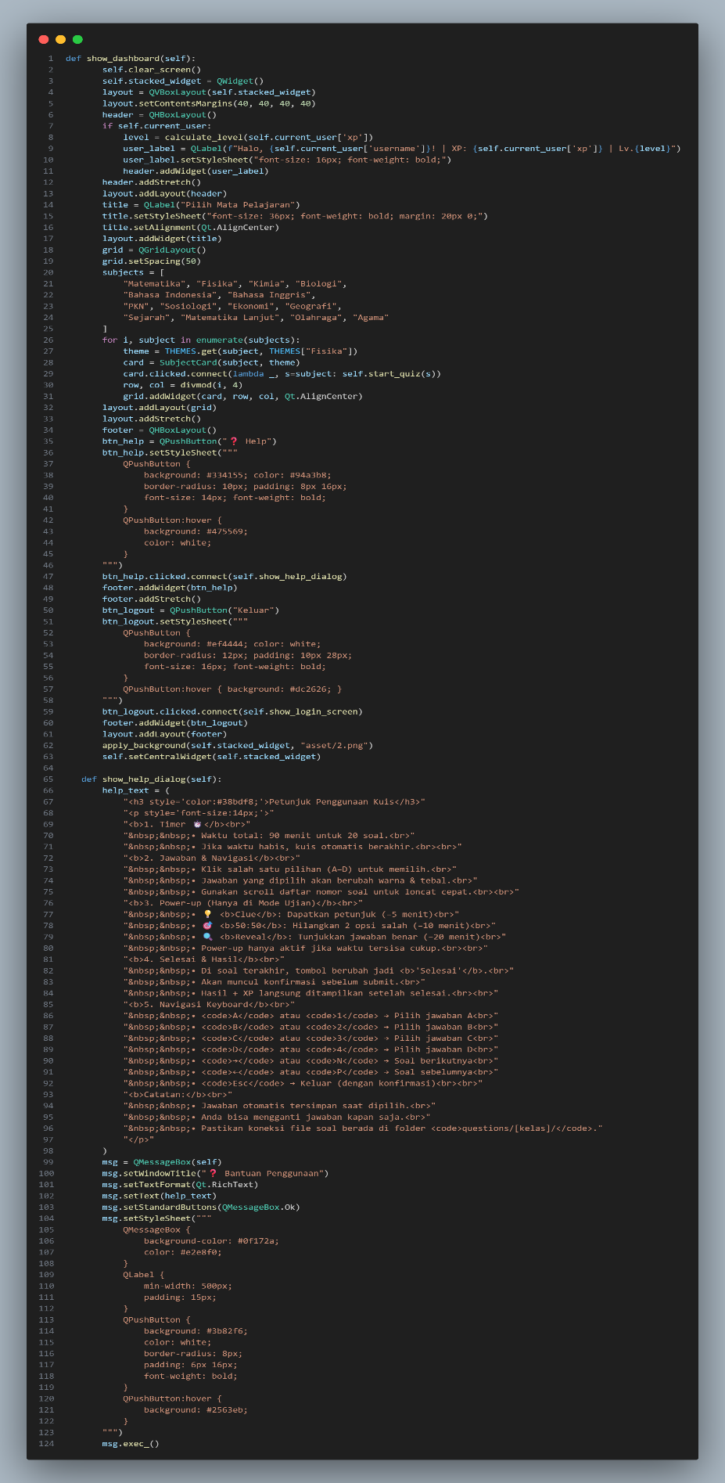

Gambar 3. 10 The code of Degichi Quiz
Source: Personal documentation
These two functions (show_dashboard and show_help_dialog) are the main part of the user interface after login. Their purpose is to guide students into the learning experience and ensure they understand how the quiz system works before entering the exam environment. Degichi Quiz is designed as a modern educational quiz platform that combines:
- Exambro-style discipline (focused exam, anti-cheating behavior)
- Quizizz-style gamification (XP, levels, power-ups, subjects selection)
And these functions are responsible for delivering exactly that.
- The Main Home Screen

show_dashboard(self) Function : This function builds the primary learning interface where students start their quiz journey. It welcomes the student, shows their progress (XP & Level), and presents different subjects like in Quizizz.
- Motivates students by showing XP growth → improves learning engagement
- Allows students to choose subjects independently
- Controls navigation, ensuring they stay inside the learning platform (Exambro-style)
- Prevents distraction — they cannot wander outside during the quiz
Key Components & Roles
- User Info Display : Shows username + XP → helps build identity and learning motivation
self.username_label = QLabel(f"Welcome, {self.current_user['username']}!")
self.xp_label = QLabel(f"XP: {self.current_user['xp']}")
- Level Calculation : The more they play → the stronger they become → adds game mechanics
level = self.current_user['xp'] // 100
self.level_label = QLabel(f"Level: {level}")
- Subject Grid : Gives access to different school subjects (Math, Physics, English, etc.)
for subject in subjects:
button = QPushButton(subject)
button.clicked.connect(lambda checked, s=subject: self.start_quiz(s))
- Click-to-Start Quiz Button : Every subject becomes an entry point to the quiz engine → fast & direct
button.clicked.connect(lambda checked, s=subject: self.start_quiz(s))
- Help Button : Leads to user guidance → reduces confusion before exam
self.help_button.clicked.connect(self.show_help_dialog)
- Logout Button : Allowed only outside the quiz → prevents cheating or escape during tests
self.logout_button.clicked.connect(self.open_logout_popup)
- Rule & Guide System
show_help_dialog(self) Function : This function informs students about how to interact with the quiz system properly. It prepares them for exam mechanics, preventing errors during answering.
Key Components & Roles
- Timer Explanation : Time limits enforce discipline like real examinations
- Answering Instructions : Clicking A/B/C/D ensures students make clear selections
help_text = ( "Select answers by clicking A/B/C/D.\n"
- Navigation Rules : Students can move questions smoothly without losing focus
- Power-Up Instructions (Quizizz mechanics)
Example:
  - 50:50 remove two wrong answers
  - Reveal correct answer but reduce remaining time
→ Fun but still learning-focused consequence
help_text = ( "You may use hints like 50:50 or Reveal Answer (time penalty).\n"
- Warning Notes : Answers saved automatically → prevents cheating like refreshing screen
help_text = ( "Your answers are saved automatically. Do not close the quiz.\n"
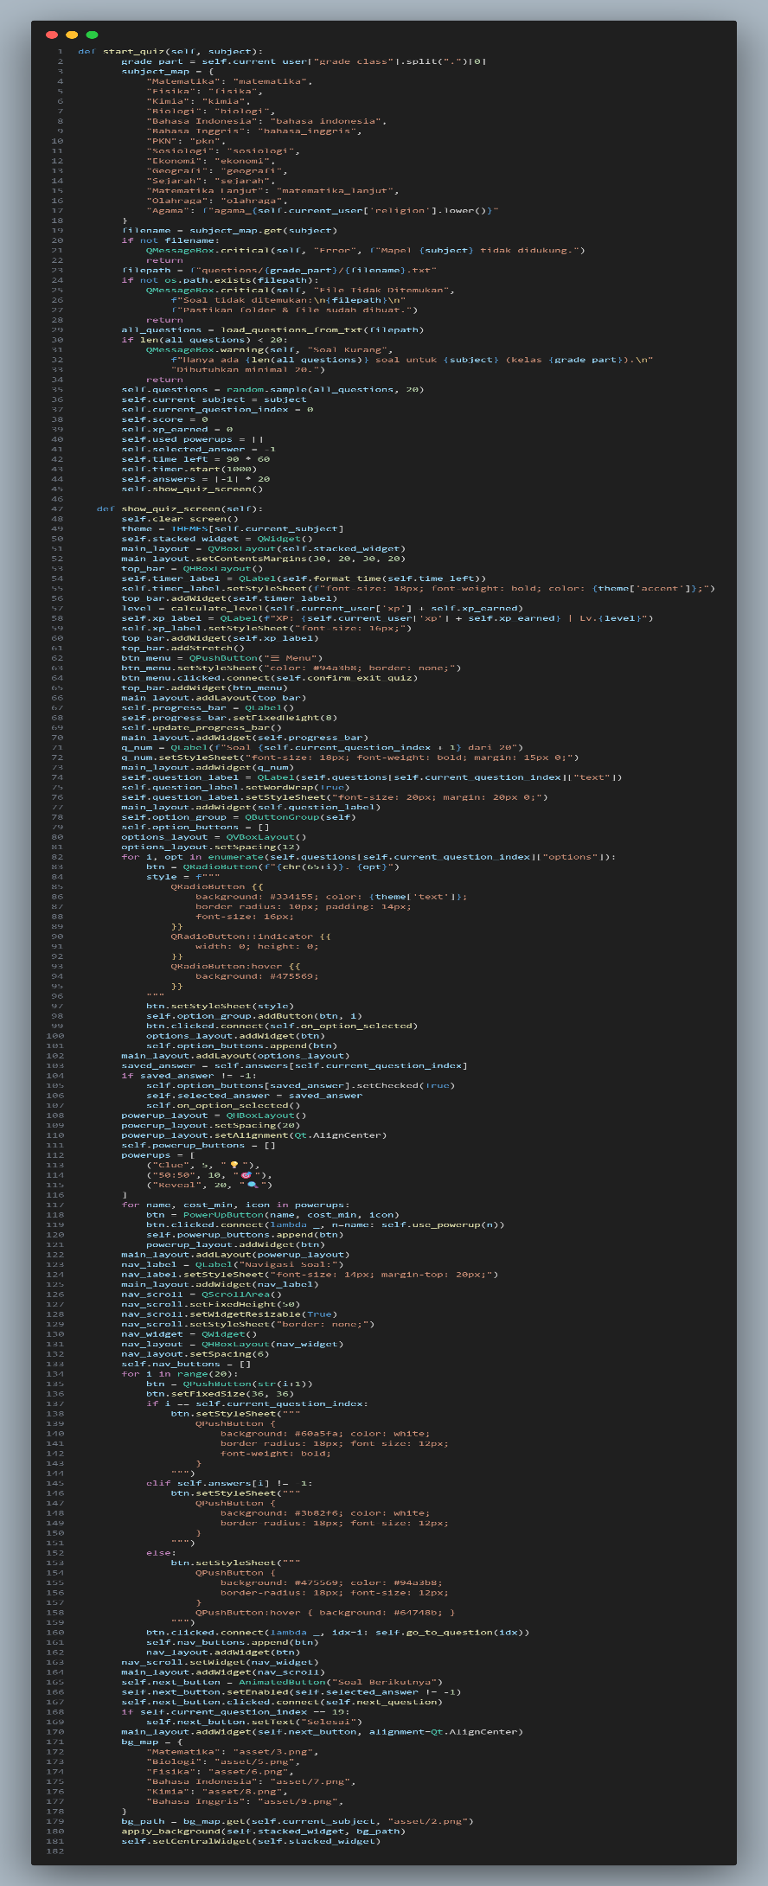

Gambar 3. 11 The code of Degichi Quiz
Source: Personal documentation

start_quiz(self, subject) Function : Prepare everything before the quiz starts and role in the progam acts as the initializer or setup engine for the quiz system.
- Map subject → filename
filename = subject_map.get(subject) : Matches the selected subject (Math, Biology, etc.) to the correct question file, so the quiz loads the proper content.
- Load questions
all_questions = load_questions_from_txt(filepath) : Reads all questions from the text file and prepares them for use in the quiz.
- Check if enough questions exist
if len(all_questions) < 20 : Makes sure the quiz has enough questions. Prevents errors or incomplete quizzes.
- Select 20 random questions
self.questions = random.sample(all_questions, 20) : Randomizes the quiz each time, so students don't get the same question order and reduces cheating.
- Initialize quiz state variables
self.current_question_index = 0
self.answers = [-1] * 20
self.xp_earned = 0
self.score = 0
show_quiz_screen(self) Function : Render the main quiz interface on the screen and role in the program serves as the UI controller and interaction layer.
- Clear old UI
self.clear_screen() : for the role in the program to removes whatever screen was shown before (menu, home, etc.) so the quiz screen can load cleanly without overlapping elements.
- Create a new container
self.stacked_widget = QWidget() : the main layout container that holds all quiz elements (timer, question, options). It is the “canvas” for the quiz screen.
- Display timer
self.timer_label = QLabel(self.format_time(self.time_left)) : Shows the countdown for the quiz.
This helps control time and creates a challenge (similar to exam or Quizizz timer).
- Display XP
self.xp_label = QLabel(f"XP: {self.current_user['xp']}") : Shows user progress/experience points. This adds a gamification element to motivate the student.
- Render question
self.question_label = QLabel(self.questions[self.current_question_index]["question"]) : Displays the current question text. This is the core content of the quiz.
- Render answer options
btn = QRadioButton(f"{chr(65+i)}. {opt}") : Creates each answer button (A, B, C, D).
This lets the student choose an answer in a clear, standard quiz format.
- Restore saved answer
saved = self.answers[self.current_question_index] : If the user goes back to a previous question, their old answer is shown again. Prevents losing work and makes navigation smooth.
- Handle option selection
btn.clicked.connect(self.on_option_selected) : Link the button to the function that record the answer. This is how the progam knows which option the student picked,
Power-ups Section – To Add optional in-game tools like clue, 50:50, reveal and the rule of this program acts as the game mechanic / gamification engine that makes the quiz feel like Quizizz.
powerups = {
'Clue': ('🔍', amount), → give hints
'50:50': ('🎲', amount), → reduce choices
'Reveal': ('💡', amount), → show correct answer
}
Navigation Controls – In the program for move to next question and acts as the flow controller for quiz progression. Keeps the quiz progressing smoothly and decides when the quiz ends.
self.next_button.clicked.connect(self.next_question)
- Saves current answer
- Moves to next question
- Detects if last question
- Changes button text to “Finish”
Background Mapping - Show a background image based on subject and Improves the visual experience and links each subject to a theme.
bg_map = {
"Matematika": "asset/3.png",
"Biologi": "asset/5.png",
}
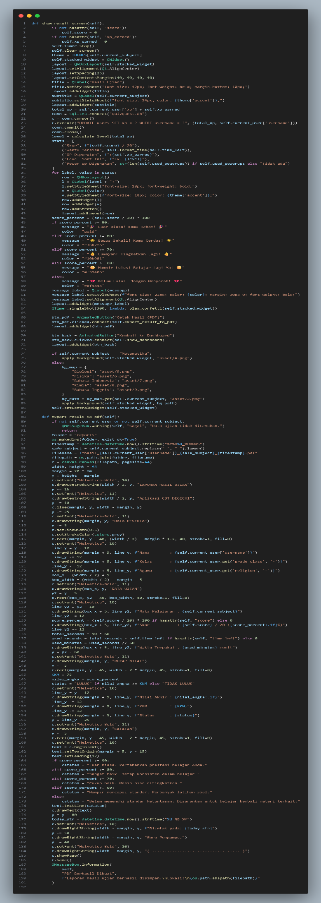

Gambar 3. 12 The code of Degichi Quiz
Source: Personal documentation
This code acts as the “Result & Reporting System” of the DEGICHI Quiz application.
It determines the student’s final score, shows pass/fail status, and generates an official report similar to a mix of Exam Browser (secure environment) and Quizizz (animations, feedback, power-ups, and XP).
show_result_screen(self) Function : To display the results page after the student finishes the quiz.

Key Components & Their Roles
- self.score and self.xp_earned : Calculate the final score and XP earned.
- self.timer.stop() : Stops the exam timer once the quiz is finished.
- UI Builder (QWidget, QVBoxLayout, QLabel) : Constructs the visual layout: title, score, subtitle, feedback messages.
- Database update : Uses SQL to update the student’s total XP.
- Status feedback : Shows motivational messages such as “Great job! 😄🔥” or “Keep trying!”
- Confetti Animation : Triggers play_confetti() if the student achieves a high score.
- Navigation Buttons : PDF export button + back-to-dashboard button.
- Background Theme : Changes background based on subject—similar to Quizizz styling.
Role in the System:
- the final score
- pass/fail status
- earned XP
- motivational feedback
- a button to export the PDF report
export_result_to_pdf(self) Function : To generate an official PDF exam report (clean and formatted like a digital report card).

Key Components & Their Roles
- Folder and filename builder
Creates the “report/” folder and generates filenames automatically:
username_subject_date.pdf
- ReportLab Canvas
Writes all exam data into a PDF.
- Data Rendering :
  - Student name
  - Class
  - Religion
  - Subject
  - Score
  - Pass/Fail status
  - Teacher notes
- KKM checking
Determines “PASS” or “FAIL” based on final score.
- Text formatting
Controls margins, fonts, and layout.
- Final save
Saves the file and shows a message: “PDF Successfully Created.”
Role in the System:
Creates a formal proof that the student has completed the quiz useful for teachers and score documentation.
Interaction with the DEGICHI Quiz System : This section supports key features of the DEGICHI Quiz ecosystem:
  - ExamBrowser-like Behavior
- Timer is strictly controlled
- UI switches to result mode with no escape
- Secure end-of-test handling
  - Quizizz-like Behavior
- XP rewards
- Motivational messages
- Confetti animations
- Subject-based themes
- Power-ups that consume time
- CBT / Report System Features
- Digital PDF report
- Pass/fail evaluation
- KKM comparison
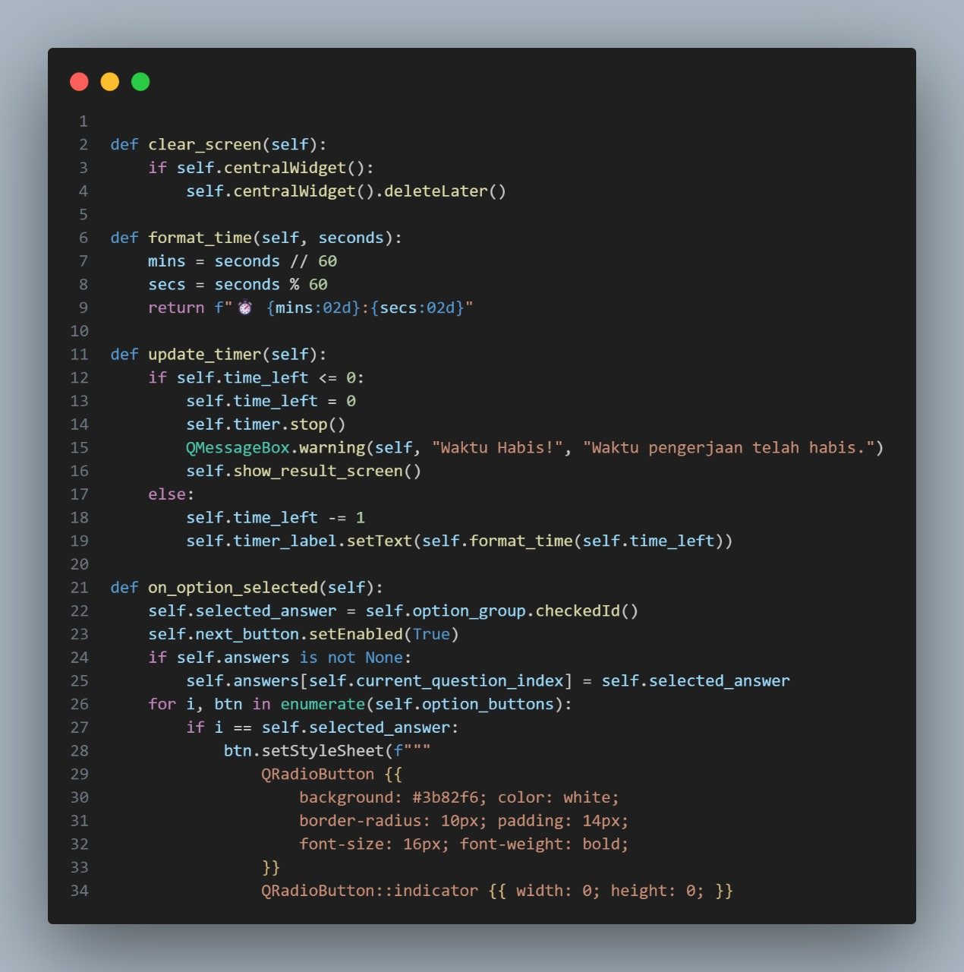
Gambar 3. 13 The code of Degichi Quiz
Source: Personal documentation

This part of the DEGICHI Quiz program handles the screen display, countdown timer, progress bar, and answer selection. These features make the quiz run smoothly, help students track their progress, and keep the exam system secure, just like a mix of ExamBrowser and Quizizz.
clear_screen(self) Function : Removes the current page/screen before loading a new one. Ensures each screen (login, dashboard, quiz, result) loads cleanly without UI elements overlapping.
This behaves like an ExamBrowser page transition always clean and isolated.
Key Components
- self.centralWidget(): the current visible page
- deleteLater(): removes the widget from memory
format_time(self, seconds) Function : Converts total seconds into MM:SS format and can be makes the countdown timer readable for students during the exam.
Key Components
- mins = seconds // 60
- secs = seconds % 60
- Returns “{mins:02d}:{secs:02d}”
update_timer(self) Function : Updates the exam timer every second.
Key Components
- self.time_left: remaining time
- self.timer.stop(): stops timer when time is up
- QMessageBox.warning(...): shows “Time’s Up!”
- self.show_result_screen(): goes to results automatically
Role in the System
- automatically ends the exam
- prevents extra time
- forces result submission
Power-ups that reduce time also affect self.time_left, so this connects Quizizz-style gameplay with exam rules.
Key Components
- self.selected_answer : stores which option is clicked
- self.option_group.checkedId() : detects the selected radio button
- Updates visual style:
  - selected = bold white button
  - unselected = theme-colored button
- self.answers[self.current_question_index] : saves answer permanently
- self.next_button.setEnabled(True) : unlocks “Next Question”
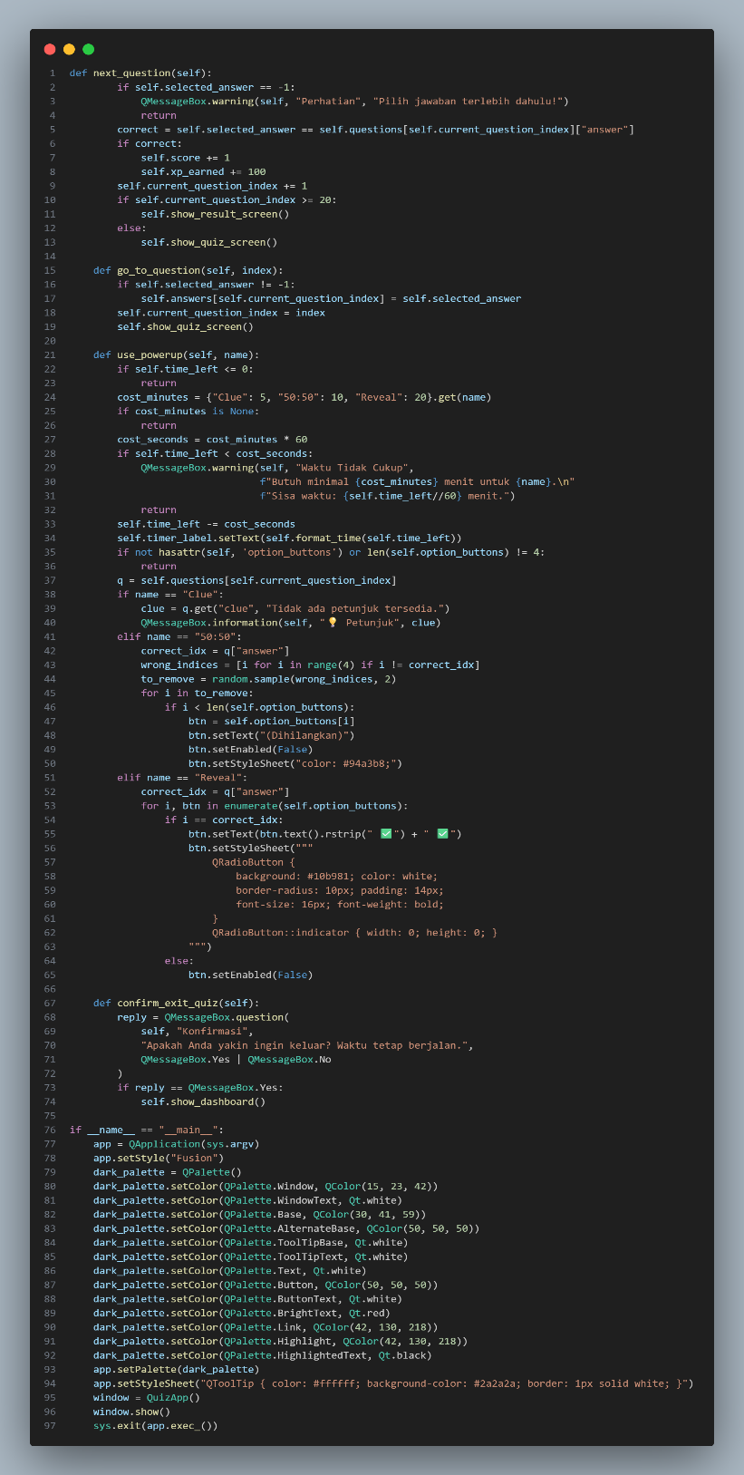
Gambar 3. 14 The code of Degichi Quiz
Source: Personal documentation

This part of the code is responsible for running the quiz process from answering questions, moving between items, using power-ups, keeping the timer active, and ensuring that the user cannot exit the quiz carelessly.
next_question(self) Function : Moves the student to the next question after selecting an answer and so role in DEGICHI Quiz is a controls progression, prevents skipping without answering, and calculates score like a CBT or exambro and Quizizz system.
Key Components:
- self.selected_answer → ensures the student chooses an answer first.
- Compares selected answer with the correct one → updates score & XP.
- self.current_question_index += 1 → moves forward.
- If question number exceeds 20 → show_result_screen().
- Else → open the next question screen.
go_to_question(self, index) Function : Allows jumping to a specific question (used in review mode or navigation UI). Role in the code to enables controlled navigation between questions while still tracking answers securely.
Key Components :
- Saves selected answer for current question.
- Updates current_question_index to the selected one.
- Reloads the quiz screen.
use_powerup(self, name) Function : Activates special features like Clue, 50:50, or Reveal each costing time.
Key Components:
- cost_minutes → determines how much time is removed.
- Subtracts time from self.time_left.
- For “Clue”: shows a hint.
- For “50:50”: hides two wrong answers.
- For “Reveal”: highlights the correct answer.
- Updates button UI (disabled state, color change)

confirm_exit_quiz(self) Function : Asks for confirmation before leaving the quiz while the timer still runs.
Key Components :
- QMessageBox.question() → confirmation pop-up.
- If “Yes” → go back to dashboard.
The main block (if __name__ == "__main__":) : Starts the application, applies theme, and opens the QuizApp window.
Key Components :
- Sets Fusion style.
- Applies dark color palette.
- Loads custom tooltip style.
- Creates and shows the main window.

APPLICATION SCREENSHOTS
Some things require visualization of this DEGICHI QUIZ which is to support the reader's visualization to be more interpreted, here are screenshots of each slide of this game:
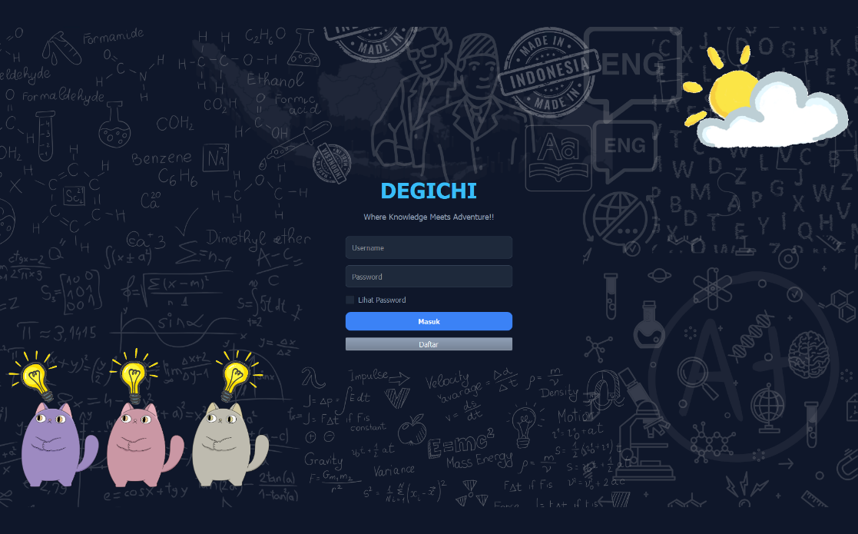
    - Main Screen
Gambar 3. 15 Main Screen of Degichi Quiz
Source: Personal documentation
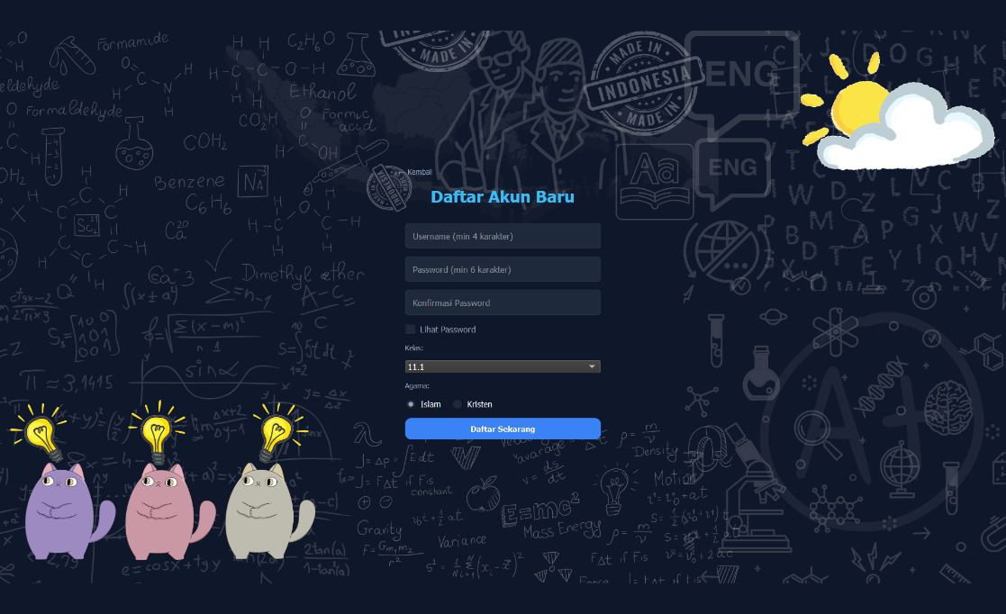
    - Log in register username
Gambar 3. 16 Log in save in Source: Personal documentation
    - Select category
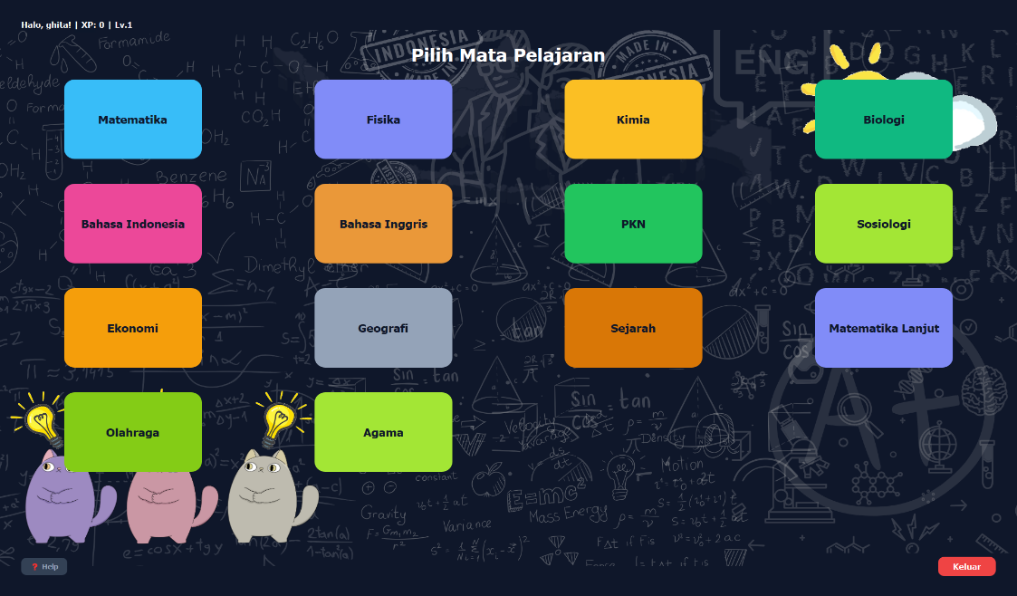
Gambar 3. 17 Category Selection Source: Personal documentation
    - Main Quiz in one of the options
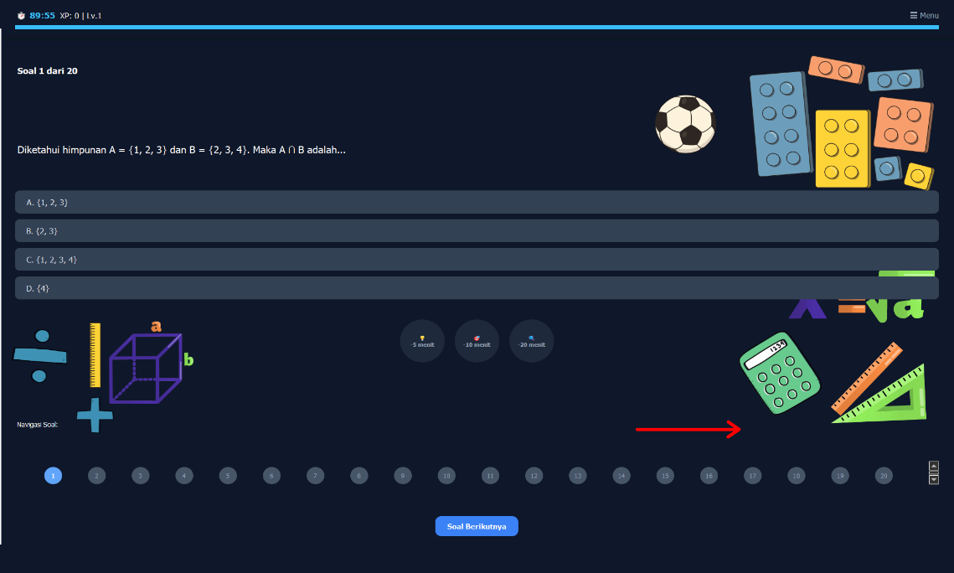
Gambar 3. 18 Main Quiz
Source: Personal documentation
    - Quiz Result in one of the options
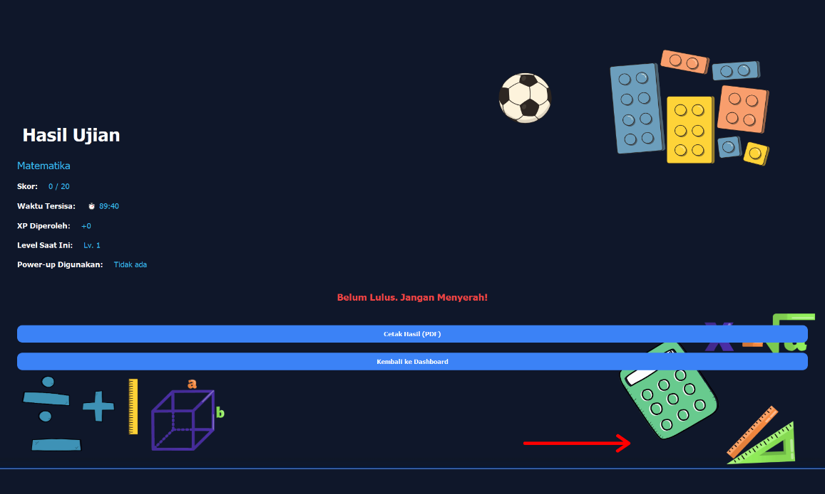
Gambar 3. 19 Quiz Result Source: Personal documentation
    - Result in PDF
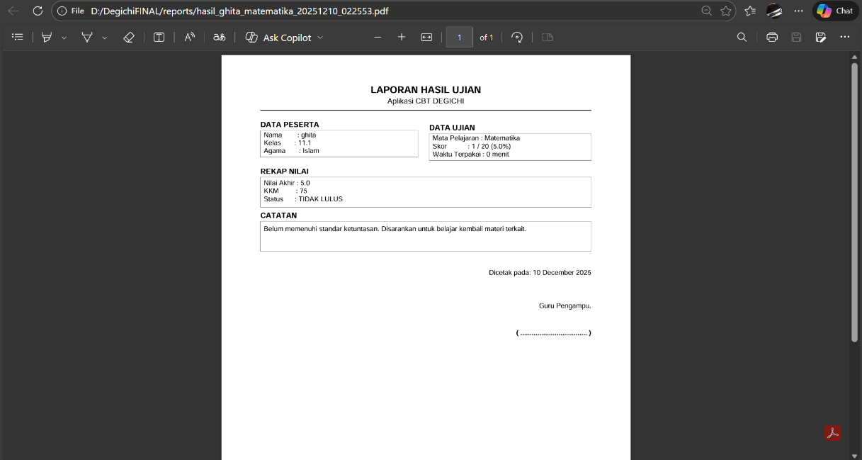
Gambar 3. 20 Result in PDF Source: Personal documentation

CHAPTER 4 ATTACHMENT

Embed File
Embed below is the complete folder of assets and the full code of DEGICHI QUIZ
DEGICHI QUIZ DRIVE LINK

REFERENCES

Citra, C. A., & Rosy, B. (2020). Keefektifan penggunaan media pembelajaran berbasis game
edukasi Quizizz terhadap hasil belajar teknologi perkantoran siswa kelas X SMK Ketintang
Surabaya. Jurnal Pendidikan Administrasi Perkantoran (JPAP), 8(2).
Marlina., & Juanda, M. F. (2025). Efektivitas penggunaan aplikasi Exambro pada evaluasi
pembelajaran geografi di Sekolah Menengah Atas Provinsi Sulawesi Selatan. Geosfera:
Jurnal Penelitian Geografi (GeoJPG), 4(1), 125–134.
Dawson, P., Van der Meer, J., Skalicky, J., & Cowley, K. (2018). Adaptive quizzes to increase motivation,
engagement and learning outcomes in a first year accounting unit. International Journal of Educational Technology in Higher Education, 15(30).
Awdry, R., & Newton, P. (2023). How common is cheating in online exams, and did it increase during the
COVID-19 pandemic? A systematic review. Journal of Academic Ethics.
UNESCO. (2023). Global Education Monitoring Report 2023. UNESCO Publishing.

